**Neo 6M documentation**

Jonas Margono – Jonas.Margono@cooper.edu

Helpful Links:

[ESP32 Documentation](https://docs.espressif.com/projects/esp-idf/en/latest/esp32/hw-reference/esp32/get-started-devkitc.html)

[Neo 6m GPS Guide](https://circuitdigest.com/microcontroller-projects/interfacing-neo6m-gps-module-with-esp32)

[Solution to weak antenna](https://forums.raspberrypi.com/viewtopic.php?t=308629)

Parts list:

* ESP32
* Jumper wires
* Neo 6M GPS module

**ESP32 Setup:**

For the sensor devilment download Arduino IDE v1.8.19. This version is compatible with some of the libraries that are used for the various sensors.

Copy the boards manager [here](https://dl.espressif.com/dl/package_esp32_index.json) and paste this link into the Additional Boards Manager URLs tab in the Settings in Arduino IDE.

Go to Tools and select ESP32 Dev Module under Tools.

**GPS Setup**

Follow the schematic below and wire the ESP32 to the GPS module. Be careful when wiring Tx and Rx pins between the two boards. Since one pin is transmitting and the other pin is receiving make sure that Tx is connected to Rx and Rx to Tx.

Schematic below:

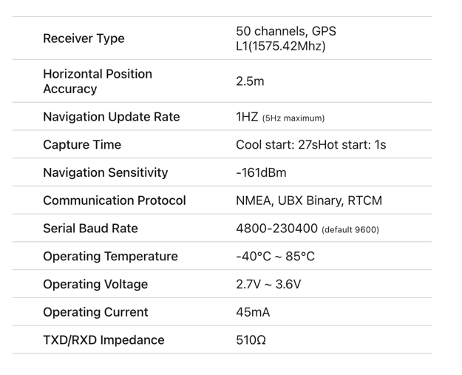

Specifications

*Note: Although some documentation suggests that the GPS module needs an external power supply, the 5V rail on the ESP32 is sufficient to power the GPS.

Programming:

The GPS outputs National Marine Electronics Association (NMEA) sentences. Read more [here](https://circuitdigest.com/microcontroller-projects/interfacing-neo6m-gps-module-with-esp32). Fortunately, there is a library that will parse through the NMEA sentence.

Download [TinyGPSPlus](https://github.com/mikalhart/TinyGPSPlus) and open the DeviceExample. Change the Baud rate in the code to 9600 (GPS module has a BAUD rate of 4800-230400).

#include <TinyGPSPlus.h>

#include <SoftwareSerial.h>

static const int RXPin = 3, TXPin = 1;

static const uint32_t GPSBaud = 9600;

// The TinyGPSPlus object

TinyGPSPlus gps;

// The serial connection to the GPS device

SoftwareSerial ss(RXPin, TXPin);

void setup()

{

Serial.begin(9600);

ss.begin(GPSBaud);

Serial.println(F("DeviceExample.ino"));

Serial.println(F("A simple demonstration of TinyGPSPlus with an attached GPS module"));

Serial.print(F("Testing TinyGPSPlus library v. ")); Serial.println(TinyGPSPlus::libraryVersion());

Serial.println(F("by Mikal Hart"));

Serial.println();

}

The highlighted sections were changed from DeviceExample.

When uploading the code make sure that the Rx and Tx connections between the GPS module and the ESP32 are not connected.

If the error “timed out for packet header” disconnect the Tx and Rx connections. Connect them back together once the code has been uploaded.

*note on Mac devices using the Arduino IDE a Python3 Path error will occur. To solve this open the terminal and make a pseudo link connection between Python and Python3. Also note that Arduino IDE 1.8.19 will have to be opened through the terminal to upload code.

**Satellite Connection**

Since the GPS module uses a small passive antenna cold starting the GPS will take some time.

*More info on [GPS](https://www.gsmarena.com/glossary.php3?term=gps#:~:text=And%20finally%20%E2%80%93%20the%20cold%20start,there%20is%20no%20known%20information.) and info on cold, warm and hot starts.

When a GPS cold starts (factory) it has no known information on the position of satellites so all the information from the satellites must be parsed from the GPS module. This can take some time.

To make a stronger connection create an aluminum foil sheet and place it underneath the antenna.

Aluminum foil

GPS Antenna

GPS module with antenna on aluminum foil

The foil will great a larger antenna and speed up the process. The ceramic antenna is not very strong so the GPS will not work inside. Make sure to be outside with no buildings above when trying to cold start the GPS.

Once the GPS has locked on to satellites the Antenna will no longer need the aluminum. Run the GPS normally without the aluminum.

It took about 15 minutes for the GPS to get signal so be patient when trying to get connection.

You successfully have setup a GPS. Happy Exploring!